|  |  |  |  |  |  |  |  |  |  |  |  |  |  |  |  |  |  |  |  |
| --- | --- | --- | --- | --- | --- | --- | --- | --- | --- | --- | --- | --- | --- | --- | --- | --- | --- | --- | --- |
| **INTERSTATE CONTAINER CORPORATION** | | | ***Date:* 06/06/2017** | ***Spec #:*** | | | | | | | | | | ***Design #:*** | | **150426-02** |  |  |  |
|  |  |
| ***Customer:*** | **DeMet's Candy** |  |  |  |  |  |  |  |  |  |  |  |  |  |  |  |  |  |  |
|  |  |  |  |  |  |  |  |  |  |  |  |  | ***Cut*** | **184 in.** | |  |  |
|  |  |  |  |  |  |  |  |  |  |  |  |  |  |  |
| ***Description:*** | **4 ct - Satin Hearts 6.5oz - SHIPPER - RSC.485/0 [Left hand 1/8"gap]** | | |  |  |  |  |  |  |  |  |  |  |  |  |  |
|  |  |  |  |  |  |  |  |  |  |  | ***Crease*** | **112 in.** | |  |  |
|  |  |  |  |  |  |  |  |  |  |  |  |  |
| ***Style:* RSC** |  | ***Revision Info:* [0] 06/06/2017:[Left hand 1/8"gap]** | |  |  |  |  |  |  |  |  |  |  |  |  |  |
|  |  |  |  |  |  |  |  |  |  |  |  |  |  |  |  |  |
|  |  |  |  |  |  |  |  |  |  |  |  |  |  |  |  |  |
| ***I.D. :* 11 x 10+5/16 x 6+3/4** | | ***Blank size:* 17+1/8 x 44+3/8** |  |  |  |  |  |  |  |  |  |  |  |  |  |  |  |  |  |
|  |  |  |  |  |  |  |  |  |  |  |  |  |  |  |  |  |
| ***Board:* 32 B K** |  | ***Combination:* 35HP - 23M - 35HP** | ***Designer:* Brian Romankow** | |  |  |  |  |  |  |  |  |  |  |  |  |  |  |  |
|  |  |  |  |  |  |  |  |  |  |  |  |  |  |  |

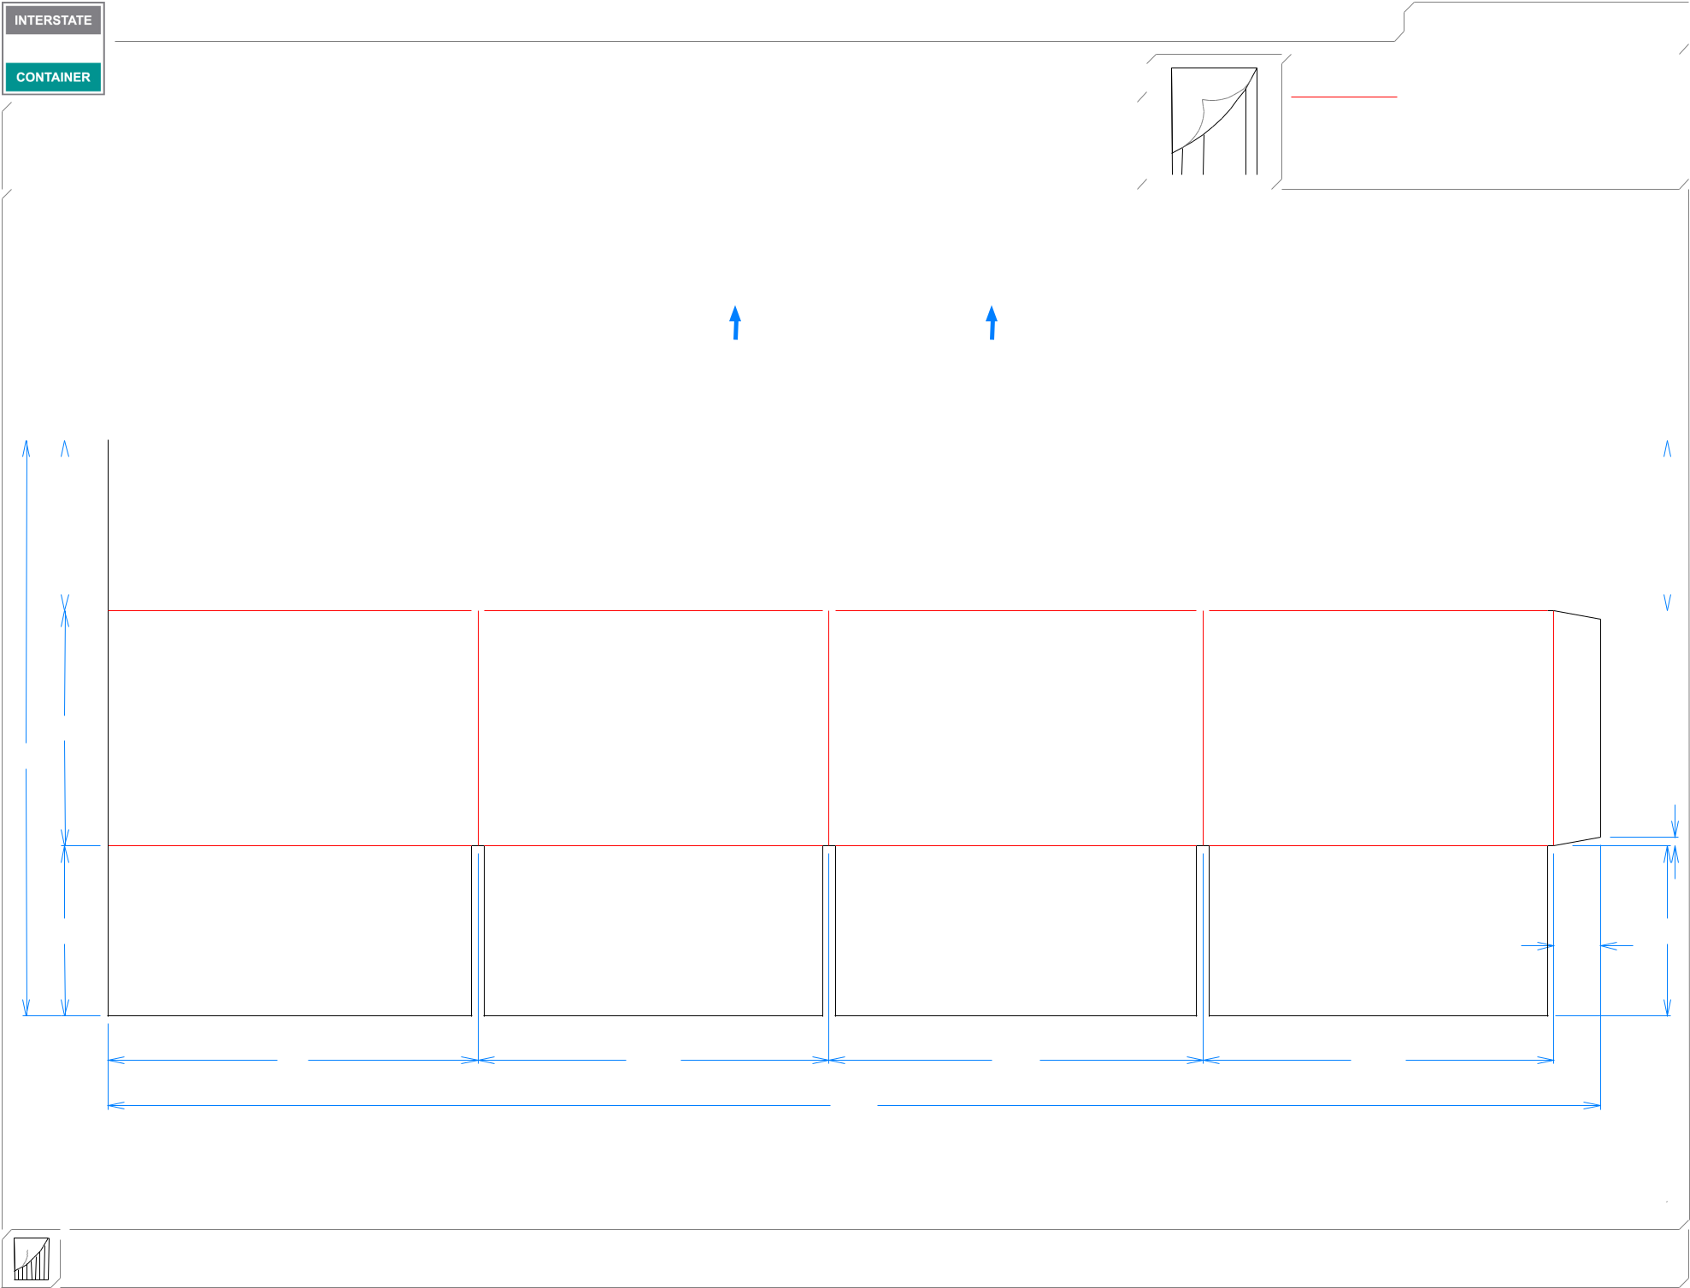

**LEAD EDGE**

**MINI FFG**

|  |  |  |  |  |  |  |  |  |  |  |  |  |  |  |
| --- | --- | --- | --- | --- | --- | --- | --- | --- | --- | --- | --- | --- | --- | --- |
|  |  |  |  |  |  |  |  |  |  |  |  |  |  |  |
| 51*/*16 | | |  |  |  |  |  |  |  |  | 51*/*16 | | | |
|  |  |  |  |  |  |  |  |  |  |  |  |  |  |  |

|  |  |  |  |
| --- | --- | --- | --- |
| 7 |  |  |  |
| 171*/*8 |  |  |  |
|  |  |  | 1*/*4 |
| 51*/*16 |  |  | 51*/*16 |
|  |  |  | 13*/*8 |
| 11 | 107*/*16 | 111*/*8 | 107*/*16 |
|  |  | 443*/*8 |  |

**inside view**

**Vertical Corrugation**

***notes:***

***Qty/unit:*** ***Area - waste:* 5.09 sq. ft** ***Waste on blank:* 3.6%** ***Piece weight - waste:* 0.52 lbs./237.89 g**